Register Number

SRM Institute of Science and Technology
Set - A
College of Engineering and Technology
School of Computing
SRM Nagar, Kattankulathur – 603203, Chengalpattu District, Tamil Nadu

Academic Year: 2025-26 (EVEN SEM)
Test: FT- IV Date:29-4-26
Course Code & Title: 21CSS303T & Data Science Duration: 100 Minutes
Year & Sem: III Year / VI Sem Max. Marks: 50

Part – B
(5 x 5 = 25 Marks)
Instructions: Answer ANY 5 questions
Q.  No | Questions | Marks | BL | CO | PO | PI Code
11 | Demonstrate the data cleaning process on a sample dataset by performing the following:  - Load a dataset  - Identify missing values  - Remove rows with missing values  - Display the cleaned dataset  import pandas as pd  # a) Load a dataset  data = {  'Name': ['Arun', 'Bala', 'Cathy', 'David'],  'Marks': [85, None, 78, 90],  'Attendance': [92, 88, None, 95]  }  df = pd.DataFrame(data)  print("Original Dataset:")  print(df)  # b) Identify missing values  print("\nMissing Values:")  print(df.isnull())  # c) Remove rows with missing values  cleaned_df = df.dropna()  # d) Display the cleaned dataset  print("\nCleaned Dataset:")  print(cleaned_df) | 5 | 3 | 3 | 5 | 5.2.3
12 | Illustrate how data wrangling operations such as merging, concatenation, and reshaping are performed by applying them on sample datasets with suitable examples.  # First dataset  df1 = pd.DataFrame({  'ID': [1, 2, 3],  'Name': ['Arun', 'Bala', 'Cathy']  })  # Second dataset  df2 = pd.DataFrame({  'ID': [1, 2, 3],  'Marks': [85, 90, 78]  })  # Merging using common column 'ID'  merged_data = pd.merge(df1, df2, on='ID')  print(merged_data) | 5 | 3 | 3 | 5 | 5.2.2
13 | Demonstrate various methods for handling missing data in datasets by applying appropriate techniques on sample data and showing their usage.  Methods for Handling Missing Data  1. Deletion Method  This method removes missing values from the dataset.  a) Row Deletion (Listwise Deletion):  Entire rows containing missing values are removed.  Example:  If a student’s mark is missing, that student record is deleted.  Justification:  Used when only a small number of rows contain missing values. It is simple and avoids wrong assumptions.  b) Column Deletion:  Entire columns are removed if they contain too many missing values.  Example:  A column with 80% missing values may be deleted.  Justification:  Useful when the column is not important and contains excessive missing values.  2. Mean Imputation  Missing numerical values are replaced with the mean (average) of the column.  Example:  Missing salary values are replaced with the average salary.  Justification:  Suitable for normally distributed numerical data and easy to implement.  Limitation:  Affected by outliers and reduces data variation.  3. Median Imputation  Missing values are replaced with the median value of the column.  Example:  Missing age values are replaced with the median age.  Justification:  Best for skewed data and datasets with outliers because median is more stable than mean.  4. Mode Imputation  Missing categorical values are replaced using the most frequently occurring value.  Example:  Missing gender values are replaced with the most common gender.  Justification:  Useful for categorical data where mean and median cannot be applied.  5. Forward Fill and Backward Fill  Forward Fill (ffill): Missing values are filled using the previous value.  Backward Fill (bfill): Missing values are filled using the next value.  Example:  In attendance records, missing values can be filled using nearby values.  Justification:  Useful in time-series data where values follow a sequence.  6. Interpolation  Missing values are estimated using surrounding values.  Example:  If temperature values for one day are missing, it can be estimated using previous and next day values.  Justification:  Suitable for continuous and time-series data where trends are important.  7. Predictive Imputation  Machine learning algorithms such as regression or classification are used to predict missing values.  Example:  Predicting missing house prices using area and location.  Justification:  Provides more accurate results when relationships exist among variables.  Limitation:  More complex and requires additional computation. | 5 | 3 | 3 | 5 | 5.2.2
14 | Apply data transformation and standardization techniques such as normalization, binning, and encoding to improve data quality. Explain with examples.  1. Normalization  Normalization is the process of scaling numerical values into a common range, usually between 0 and 1, so that all features contribute equally to the model.  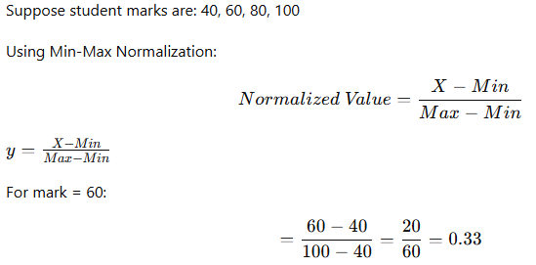Justification:  Normalization is useful when attributes have different units such as age, salary, and marks. It improves the performance of distance-based algorithms like KNN and clustering.  2. Binning  Binning is the process of converting continuous numerical values into discrete intervals or groups called bins.  Example:  Age values: 18, 22, 27, 35, 42  Can be grouped as:  18–25 → Young  26–35 → Adult  36–45 → Senior  Justification:  Binning reduces noise and simplifies analysis by converting exact values into meaningful categories. It is useful in classification tasks and pattern identification.  3. Encoding  Encoding is used to convert categorical data into numerical form so that machine learning models can process it.  Types of Encoding:  a) Label Encoding  Each category is assigned a unique number.  Example:  Gender:  Male → 0  Female → 1  Justification:  Simple and suitable when categories have an order or when binary categories exist.  b) One-Hot Encoding  Each category is converted into a separate binary column.  Example:  Color: Red, Blue, Green  Converted as:  Color Red Blue Green  Red 1 0 0  Blue 0 1 0  Green 0 0 1  Justification:  Useful when categories do not have any order. It prevents the model from assuming numerical ranking. | 5 | 4 | 4 | 5 | 5.3.3
15 | Demonstrate how data trends can be visualized effectively by performing the following:  - Plot a line graph for given data  - Add title, labels, and legend  - Customize the plot for better readability  # Import required library  import matplotlib.pyplot as plt  # Given data  days = [1, 2, 3, 4, 5]  sales = [200, 350, 300, 500, 450]  # Plot line graph  plt.plot(days, sales, marker='o', linestyle='-', label='Sales')  # Add title and labels  plt.title("Sales Trend Over 5 Days")  plt.xlabel("Days")  plt.ylabel("Sales Amount")  # Add legend  plt.legend()  # Customize plot for better readability  plt.grid(True) # Display grid  plt.xticks(days) # Show all day values on x-axis  plt.tight_layout() # Adjust layout properly  # Display the graph  plt.show() | 5 | 4 | 4 | 5 | 5.3.3
16 | Evaluate and compare line plot, bar plot, histogram, scatter plot, and box plot by examining their characteristics, use cases, and differences, and illustrate each with suitable real-world examples.  1. Line Plot  A line plot is used to show trends or changes over time by connecting data points with lines.  Example:  Monthly electricity consumption of a house from January to December.  Real-World Use:  Used in stock market analysis, temperature monitoring, and sales growth tracking.  Analysis:  It helps identify increasing trends, decreasing trends, and seasonal patterns over a continuous period.  2. Bar Plot  A bar plot is used to compare values among different categories using rectangular bars.  Example:  Number of students in different departments such as CSE, ECE, and Mechanical.  Real-World Use:  Used in comparing product sales, department performance, and survey results.  Analysis:  It clearly shows which category has the highest or lowest value.  3. Histogram  A histogram is used to show the frequency distribution of continuous numerical data by dividing values into intervals called bins.  Example:  Distribution of students’ exam marks grouped into ranges like 0–20, 21–40, etc.  Real-World Use:  Used in age distribution, salary analysis, and test score analysis.  Analysis:  It helps understand data spread, concentration, and whether the data is normally distributed or skewed.  4. Scatter Plot  A scatter plot is used to show the relationship between two numerical variables using points.  Example:  Study hours vs exam marks of students.  Real-World Use:  Used in business, healthcare, and machine learning to find correlations.  Analysis:  It helps identify positive correlation, negative correlation, or no relationship between variables.  5. Box Plot  A box plot is used to display the spread of data using minimum, maximum, median, quartiles, and outliers.  Example:  Salary distribution of employees in a company.  Real-World Use:  Used in statistical analysis, quality control, and performance comparison.  Analysis:  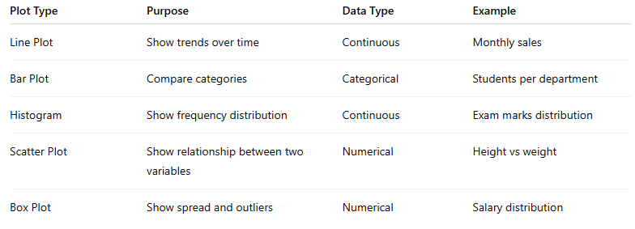 | 5 | 4 | 4 | 5 | 5.3.3
17 | Examine and construct statistical visualizations such as distribution plots and pair plots using Seaborn, and evaluate the advantages of Seaborn for effective data interpretation with suitable examples.  1. Distribution Plot  A distribution plot is used to visualize how values are distributed in a dataset. It helps identify the shape of the data such as normal distribution, skewness, and spread.  Example:  Visualizing the distribution of students’ marks.  Python Code:  import seaborn as sns  import matplotlib.pyplot as plt  marks = [45, 50, 55, 60, 65, 70, 75, 80, 85, 90]  sns.histplot(marks, kde=True)  plt.title("Distribution of Student Marks")  plt.xlabel("Marks")  plt.ylabel("Frequency")  plt.show()  Analysis:  The histogram shows how marks are spread across students, and the KDE (Kernel Density Estimate) line gives a smooth curve representing the distribution pattern.  2. Pair Plot  A pair plot is used to visualize relationships between multiple numerical variables in a dataset. It creates scatter plots for variable pairs and histograms for individual features.  Example:  Analyzing the Iris flower dataset.  Python Code:  import seaborn as sns  import matplotlib.pyplot as plt  # Load built-in dataset  data = sns.load_dataset("iris")  # Create pair plot  sns.pairplot(data, hue="species")  plt.show()  Analysis:  The pair plot helps compare sepal length, sepal width, petal length, and petal width for different flower species. It shows correlations and class separation clearly.  Advantages of Using Seaborn  1. Attractive Default Styles  Seaborn automatically provides beautiful themes and color palettes, making plots more readable and professional without extra coding.  2. Easy Statistical Visualization  Complex statistical plots like heatmaps, pair plots, violin plots, and distribution plots can be created using simple commands.  3. Better Integration with Pandas  Seaborn works directly with Pandas DataFrames, making it easy to visualize structured datasets.  4. Built-in Dataset Support  It provides built-in datasets like Iris, Tips, Titanic, etc., useful for learning and testing.  5. Improved Data Interpretation  It helps identify patterns, relationships, trends, outliers, and distributions quickly, supporting better decision-making. | 5 | 4 | 4 | 5 | 5.3.4

Part – C
(1 x 15= 15 Marks)
Instructions: Answer ALL the questions
Q.  No | Questions | Marks | BL | CO | PO | PI  Code
15 | A healthcare organization collects patient records from multiple hospitals and diagnostic centers. The dataset contains the following issues:  - Missing values in columns like Age (NaN, 0, -2) and Blood_Pressure (NaN, 0)  - Duplicate records with the same Patient_ID  - Inconsistent formats in:  - Patient_Name: extra spaces and mixed cases (e.g., "john doe ", "JOHN DOE")  - Gender: "Male", "M", "female", "F"  - Extreme values (outliers) in Cholesterol_Level (normal range 150–240, but some values exceed 500)  - Mixed date formats in Visit_Date (e.g., "2024-01-10" and "10/01/24")  Question:  Design a complete data cleaning and preparation pipeline to make the dataset suitable for analysis. Your answer should include:  - Handling missing data  - Removing duplicates  - Data transformation and standardization  - Outlier detection and treatment  - Preparing the dataset for analysis  a) Handling Missing Data  Missing values are present in columns like Age and Blood_Pressure, including invalid values such as NaN, 0, and negative values.  Steps:  1. Identify Missing and Invalid Values  Age → NaN, 0, -2 are invalid  Blood_Pressure → NaN, 0 are invalid  2. Replace Invalid Values with NaN  This helps treat all invalid entries uniformly.  Example:  Age = 0 → NaN  Age = -2 → NaN  Blood_Pressure = 0 → NaN  3. Fill Missing Values  Use Median for Age (less affected by outliers)  Use Mean or Median for Blood_Pressure depending on distribution  Justification:  Median is preferred for medical data because extreme values may affect the mean.  b) Removing Duplicates  Duplicate records exist with the same Patient_ID.  Steps:  1. Identify Duplicate Records  Check repeated Patient_ID values.  2. Remove Duplicate Entries  Keep only the first valid occurrence.  Example:  If Patient_ID = P101 appears 3 times, retain one record and remove the rest.  Justification:  Duplicate records create bias and incorrect statistical analysis.  c) Data Transformation and Standardization  Data inconsistency exists in names, gender values, and date formats.  1. Standardizing Patient_Name  Problem:  "john doe "  "JOHN DOE"  Solution:  Remove extra spaces using strip()  Convert to proper title case using title()  Result:  "John Doe"  2. Standardizing Gender  Problem:  Male, M, female, F  Solution:  Convert all values into a single standard format:  Male, M → Male  Female, F → Female  Justification:  Improves consistency for grouping and analysis.  3. Standardizing Visit_Date  Problem:  Mixed formats:  2024-01-10  10/01/24  Solution:  Convert all dates into one standard format:  YYYY-MM-DD  Result:  2024-01-10  Justification:  Uniform date format helps in time-based analysis and reporting.  d) Outlier Detection and Treatment  Extreme values exist in Cholesterol_Level, where normal range is 150–240 but some values exceed 500.  Steps:  1. Detect Outliers  Use:  Box Plot  IQR (Interquartile Range) Method  Z-score Method  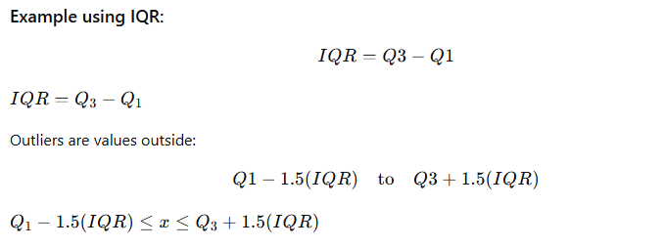  2. Treat Outliers  Options:  Remove extremely unrealistic values  Replace using median  Cap values using upper limit (Winsorization)  Example:  Cholesterol = 520 → replace with median or upper acceptable limit  Justification:  Prevents outliers from distorting analysis and model performance.  e) Preparing the Dataset for Analysis  After cleaning, the dataset must be prepared for machine learning or reporting.  Steps:  1. Encode Categorical Variables  Convert Gender into numeric form:  Male → 0  Female → 1  This helps machine learning models process the data.  2. Normalize Numerical Features  Apply normalization to:  Age  Blood_Pressure  Cholesterol_Level  This ensures all values are on a similar scale.  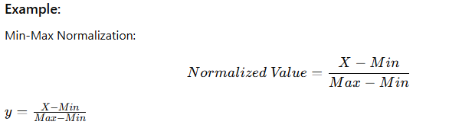3. Verify Final Dataset  Check:  No missing values  No duplicates  Standardized formats  No extreme outliers  Correct data types | 15 | 4 | 5 | 5 | 5.2.4
(OR)
16 | You are given a dataset of student performance containing attributes such as Marks, Attendance, Study_Hours, Gender, and Result. The dataset contains the following inconsistencies and extreme values:  - Marks include invalid values such as -10 and 150 (valid range: 0–100)  - Attendance includes values above 100% and below 0%  - Study_Hours contains unrealistic values such as 0 and 15 hours per day  - Gender is inconsistently represented as "Male", "M", "female", "F"  - Presence of outliers in marks and study hours  Question:  Develop a comprehensive data visualization strategy to extract meaningful insights from the dataset. Your answer should include:  - Selection of appropriate plots  - Use of Matplotlib and Seaborn with eg. code  - Customization techniques  - Identification of trends and outliers  - Use of multiple plots for comparison  Solution  a) Selection of Appropriate Plots  Different plots are selected based on the type of data and analysis required.  1. Histogram  Used for:  Marks  Attendance  Study_Hours  Purpose:  To understand frequency distribution and identify unusual values like -10, 150, or 15 study hours.  Example Insight:  Helps detect whether marks are normally distributed or highly skewed.  2. Box Plot  Used for:  Marks  Study_Hours  Purpose:  To detect outliers clearly using quartiles and whiskers.  Example Insight:  Marks = 150 and Study_Hours = 15 will appear as outliers.  3. Count Plot / Bar Plot  Used for:  Gender  Result  Purpose:  To compare category frequencies.  Example Insight:  Helps identify inconsistent gender entries like Male, M, Female, F.  4. Scatter Plot  Used for:  Study_Hours vs Marks  Attendance vs Marks  Purpose:  To identify relationships and correlations.  Example Insight:  Students with higher study hours may have better marks.  5. Pair Plot  Used for:  Marks  Attendance  Study_Hours  Purpose:  To compare multiple variables together and observe patterns.  Example Insight:  Shows overall relationships among all numerical features.  b) Use of Matplotlib and Seaborn with Example Code  Example Python Code  import pandas as pd  import matplotlib.pyplot as plt  import seaborn as sns  # Sample dataset  data = pd.DataFrame({  'Marks': [85, 90, -10, 150, 70, 65, 95],  'Attendance': [90, 105, 80, -5, 75, 88, 92],  'Study_Hours': [2, 4, 0, 15, 5, 3, 6],  'Gender': ['Male', 'M', 'female', 'F', 'Male', 'Female', 'M'],  'Result': ['Pass', 'Pass', 'Fail', 'Pass', 'Pass', 'Fail', 'Pass']  })  # Histogram for Marks  plt.figure(figsize=(8,5))  plt.hist(data['Marks'], bins=10)  plt.title("Distribution of Marks")  plt.xlabel("Marks")  plt.ylabel("Frequency")  plt.grid(True)  plt.show()  # Boxplot for Study Hours  plt.figure(figsize=(8,5))  sns.boxplot(y=data['Study_Hours'])  plt.title("Box Plot of Study Hours")  plt.show()  # Scatter plot  plt.figure(figsize=(8,5))  sns.scatterplot(x='Study_Hours', y='Marks', data=data)  plt.title("Study Hours vs Marks")  plt.show()  # Count plot for Gender  plt.figure(figsize=(8,5))  sns.countplot(x='Gender', data=data)  plt.title("Gender Distribution")  plt.show()  # Pair plot  sns.pairplot(data[['Marks', 'Attendance', 'Study_Hours']])  plt.show()  c) Customization Techniques  Customization improves readability and understanding.  Common Customizations  1. Title  Clearly describes the graph.  Example:  plt.title("Distribution of Marks")  2. Axis Labels  Helps identify variables.  Example:  plt.xlabel("Marks")  plt.ylabel("Frequency")  3. Grid  Improves readability.  Example:  plt.grid(True)  4. Figure Size  Makes the plot clearer.  Example:  plt.figure(figsize=(8,5))  5. Legend  Useful when comparing multiple categories.  Example:  plt.legend()  d) Identification of Trends and Outliers  Trends  Scatter Plot Analysis  Study_Hours vs Marks helps identify:  Positive correlation → more study leads to better marks  Negative correlation → unusual academic behavior  Attendance vs Marks  Shows whether regular attendance improves performance.  Outliers  Box Plot Analysis  Detects extreme values such as:  Marks = 150  Marks = -10  Study_Hours = 15  Study_Hours = 0  These values require correction or removal during preprocessing.  e) Use of Multiple Plots for Comparison  Using multiple plots provides deeper understanding.  Example Comparisons  1. Histogram + Box Plot  For Marks:  Histogram shows distribution  Box plot confirms exact outliers  Together they provide better insight.  2. Scatter Plot + Pair Plot  For relationships:  Scatter plot focuses on one relationship  Pair plot shows all relationships together  This improves decision-making.  3. Count Plot + Bar Plot  For Gender:  Helps identify duplicate category representation such as:  Male and M  Female and F  This supports standardization. | 15 | 4 | 5 | 5 | 5.3.4

Course Outcome (CO) and Bloom’s level (BL) Coverage in Questions

